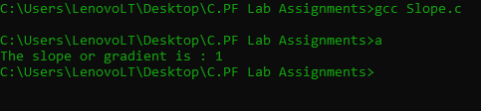

#include<stdio.h>

int main()

{

int x1 = 5 , y1 = 4 , x2 = 3 , y2 = 2 ;

int S = (y2-y1)/(x2-x1) ;

printf("The slope or gradient is : %d",S);

return 0 ;

}